Foundation

#### Coffee at Origin

* Arabica
  + Higher ______, sweeter, and lighter body
* Robusta
  + Lower acidity, more ______, and heavier body
* Coffee Tree + Fruit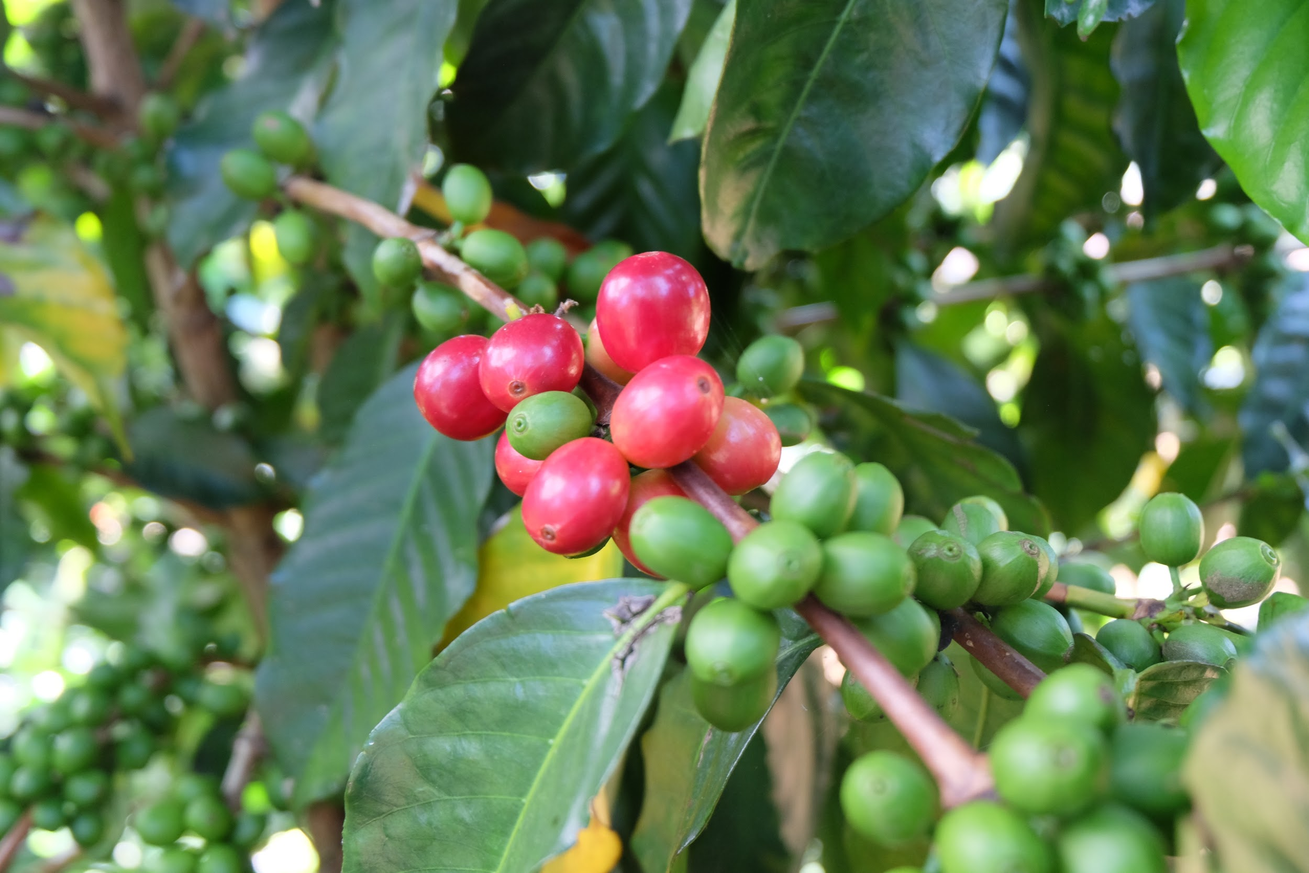
  + Processing
    - Different methods of removing seeds from fruit
    - Natural/Dry Process
    - Semi-Washed/Honeyed
    - Washed/Wet process
  + Shipping
    - Via Sea, Air
  + Roasting
    - Chemical reactions in the seed
  + Brewing
    - Extracting solubles!

#### Extraction

Dissolved coffee compounds from the bean

SCA Gold Cup recommended range 18-22%

Too much extraction results in _______, woody, or tannic flavors

Too little extraction results in sour, ________, salty, or acidic flavors

Strength

Also called **concentration**

The ____________ of the cup that is dissolved solids

#### Ratio

Dry coffee to water

Minimum ______ to ______

SCA recommends 55g per liter (around 1:18)

#### Espresso

14 to 20g for a __________ __________

#### Grind Setting

Affects rate of __________ through change in surface area

___________ water can flow through coffee bed

#### Grind Setting Activity

*After brewing each, take note of drip-out time, flavor, aroma, etc.*

Brew 1 time: Notes:

Brew 2 time: Notes:

#### 

#### Grind vs Time

Amount of contact time impacts __________ of dissolved solids

More contact time = more extraction

Meaning, there is an appropriate _______ _______ for different methods based on contact time

General contact times for brew methods:

Single cup filter = 1-3 mins, Batch filter coffee= 4-6 minutes, Espresso = 20-30 seconds

**Grind size should match and correspond to different brew methods.**

I.E. Don’t use espresso-type grind for immersion brewing(French press, etc.)

#### Water Temperature

195 to 205°F

Too hot can lead to __________ and bitter flavors

Not hot enough can lead to under-extraction and sour or grassy flavors

#### Turbulence

Agitation or stirring increases extraction

Can be applied with various methods like:

* Stirring the coffee slurry
* Spreading total water dispensed over longer time

#### Water Quality

Varies in different regions

**Hard water** has a high mineral content, **can cause limescale buildup**

_____ water has a low mineral content

Should be free from taints or odors

#### Filters

Paper:

Metal / Mesh:

Cloth:

#### Pressure

Impacts rate of extraction

Increased pressure → Increased _________

E.g. Pump pressure on espresso machine at 10 Bar instead of 8 Bar; more pressure applied in aeropress

#### Maintaining Coffee Freshness

Keeping away from:

Oxygen

* Causes oxidation and staling of the coffee

Moisture

* Can cause bacterial or fungal growth

High or low temperatures (Outside of 60°-75° F)

* High temperatures increase rate of oxidation
* Low temperatures promote condensation(moisture)

Light

* Promotes increased oxidation

Ideal spot is an airtight container kept in a cool, dark, dry space.

#### Cleaning

Prevents buildup of __________ and __________  
__________ or __________ flavors can develop without regular cleaning  
Use detergents or solutions intended for coffee equipment (mild/unscented)

#### Hot Holding (heated and not heated)

Breakdown in aroma and taste (both)  
Loss of temperature (not heated)  
Evaporation(heated)  
Loss of sweetness and acidity(both)

#### 

#### Brewing Methods

*Write down at least one example of each.*

Immersion:

Gravity:

Pressure: